CREATE TABLE flights (

f_no varchar(20),

f_name varchar(30),

f_source varchar(20),

f_dest varchar(20)

) ;

INSERT INTO flights (f_no,f_name,f_source,f_dest) VALUES('123987','etihad airways','abu dhabi','mumbai');

INSERT INTO flights (f_no,f_name,f_source,f_dest) VALUES ('23758','jet airways','delhi','london');

INSERT INTO flights (f_no,f_name,f_source,f_dest) VALUES('125687','etihad airways','abu dhabi','new york');

INSERT INTO flights (f_no,f_name,f_source,f_dest) VALUES('354365','emirates airways','dubai','new york');

INSERT INTO flights (f_no,f_name,f_source,f_dest) VALUES('253466','air india','abu dhabhi','mumbai');

INSERT INTO flights (f_no,f_name,f_source,f_dest) VALUES('246464','united airways','dubai','new york');

INSERT INTO flights (f_no,f_name,f_source,f_dest) VALUES('46575','lufthansa airways','frankfurt','mumbai');

INSERT INTO flights (f_no,f_name,f_source,f_dest) VALUES('243546','jet airways','frankfurt','mumbai');

INSERT INTO flights (f_no,f_name,f_source,f_dest) VALUES('32536','british airways','delhi','london');

INSERT INTO flights (f_no,f_name,f_source,f_dest) VALUES('35346','emirates airways','dubai','mumbai');

select * from flights;

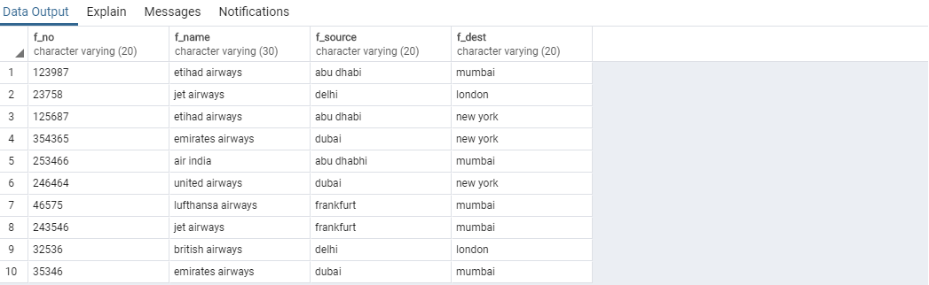

ALTER TABLE flights

ADD COLUMN source_airport varchar(100);

select * from flights;

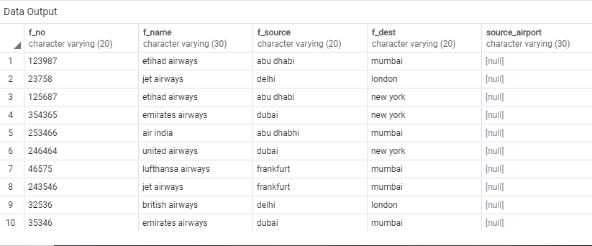

select count(*) from flights;

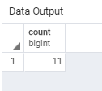

ALTER TABLE flights DROP COLUMN source_airport;

select * from flights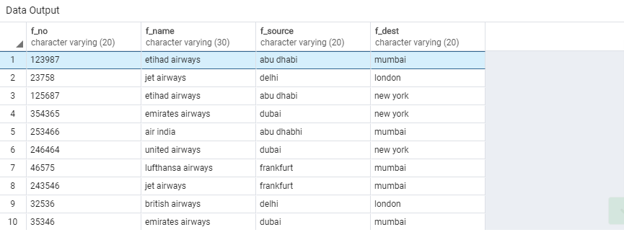

CREATE TABLE passenger (

P_id int ,

Fname varchar(20),

Lname varchar(20) ,

age int,

mobileno varchar(30),

email varchar(30),

password varchar(30),

f_no varchar(30) ,

PRIMARY KEY (P_id)

);

select * from passenger;

INSERT INTO passenger (P_id, Fname, Lname, age, mobileno, email, password, f_no) VALUES

(1, 'aditi', 's', 32, '1212121212', '1@1.cc', '123123123', 123987),

(2, 'akshay', 'p', 19, '1111111111', '1@1.cc', '111111111', 253466),

(3, 'Roy', 'c', 54, '1111111111', 'Royce@gmail.com', '123123123', 354365),

(4, 'Rahul', 'd', 40, '9090909090', 'rahul@gmail.com', '123123123', 253466),

(5, 'atif', 'k', 90, '1111111111', '12@2.cc', '123123123', 23758);

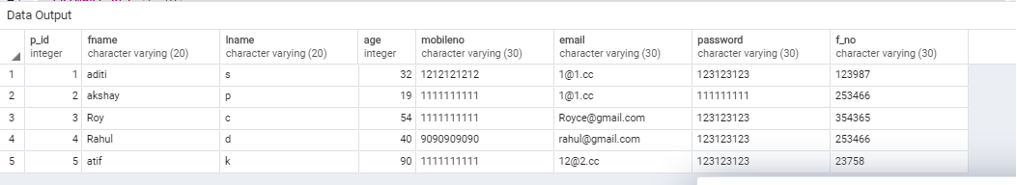

update passenger set email='a@l.cc' where p_id=1;

select * from passenger;

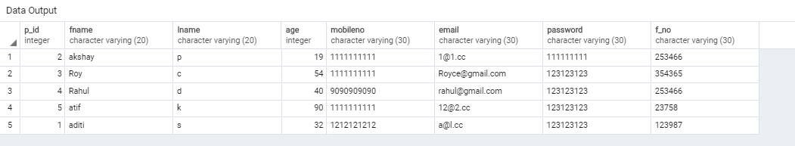

CREATE TABLE IF NOT EXISTS tickets (

t_no int,

p_id int,

t_fare int

);

INSERT INTO tickets(t_no, p_id, t_fare) VALUE(19116, 1, 30000),(12934, 2, 45000),(19115, 3, 50000),(12876, 4, 300000),(19001, 5, 300000);

select * from tickets;

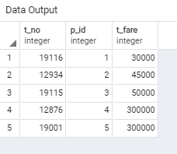

update tickets set t_fare='340000' where p_id=1;

select * from tickets;

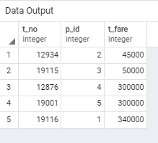

select sum(totalcost) from supply;

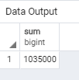

create table Timing(

DEPARTS VARCHAR(20),

ARRIVES VARCHAR(20),

f_no varchar(20));

select * from timing;

INSERT INTO timing (f_no,departs,arrives) VALUES('35346','12:10','5:00');

INSERT INTO timing (f_no,departs,arrives) VALUES('46575','1:10','9:00');

INSERT INTO timing (f_no,departs,arrives) VALUES('243546','9:40','17:00');

INSERT INTO timing (f_no,departs,arrives) VALUES('23758','3:30','19:00');

INSERT INTO timing (f_no,departs,arrives) VALUES('125687','19:30','5:00');

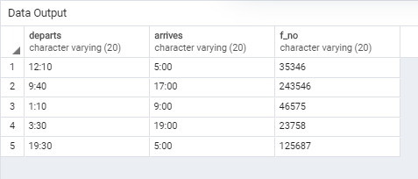

alter table timing

add column date varchar(30);

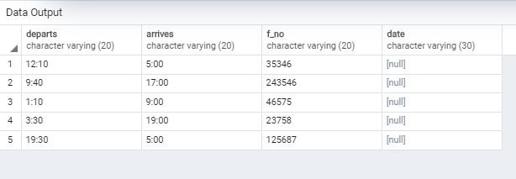

update timing set date='12/10/19' where f_no='35346';

update timing set date='7/12/19' where f_no='23758';

update timing set date='17/5/19' where f_no='243546';

update timing set date='27/4/19' where f_no='46575';

update timing set date='23/11/19' where f_no='125687';

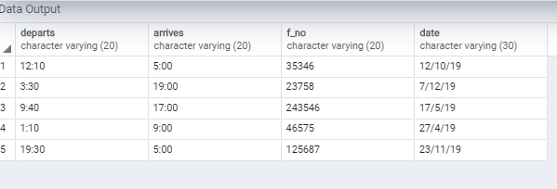

alter table flights

add primary key(f_no);

ALTER TABLE Timing

ADD foreign KEY (f_no) references flights (f_no);

ALTER TABLE Timing

ADD foreign KEY (f_no) references flights (f_no);

ALTER TABLE tickets

ADD foreign KEY (p_id) references passenger (p_id);

SELECT f_name,P_id, Fname, Lname, age, mobileno, email

FROM Passenger JOIN flights

ON passenger.f_no = flights.f_no

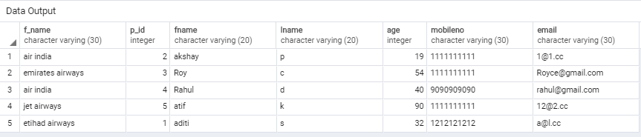

SELECT f.f_no

, f.f_name

,f.f_source

,f.f_dest

, p.fname

, p.lname

,t.date

,t.departs

,t.arrives

FROM flights f

join passenger p on f.f_no = p.f_no

join timing t on f.f_no= t.f_no

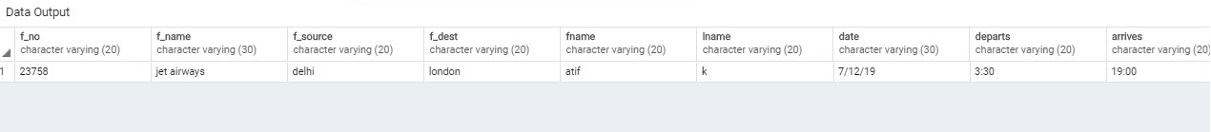

Create View PASSENGERINFORMATIONs

AS

SELECT fname,lname,age,f.f_no,f.f_name, f.f_source,f.f_dest

FROM passenger p, flights f

where p.f_no = f.f_no

Select * from passengerinformations

